Nathan Gaffney

24-November-2014

CST-183-FA110-14FA-COURSE

This program will create a ticket for parking based on user information input.

Start

Int time

String model

String make

String color

String license

String name

String badge

Int purchased

Get model

Get make

Get color

Get license

Get name

Get badge

Get purchased

Get time

If time > purchased

Make ticket

Else

No ticket

End

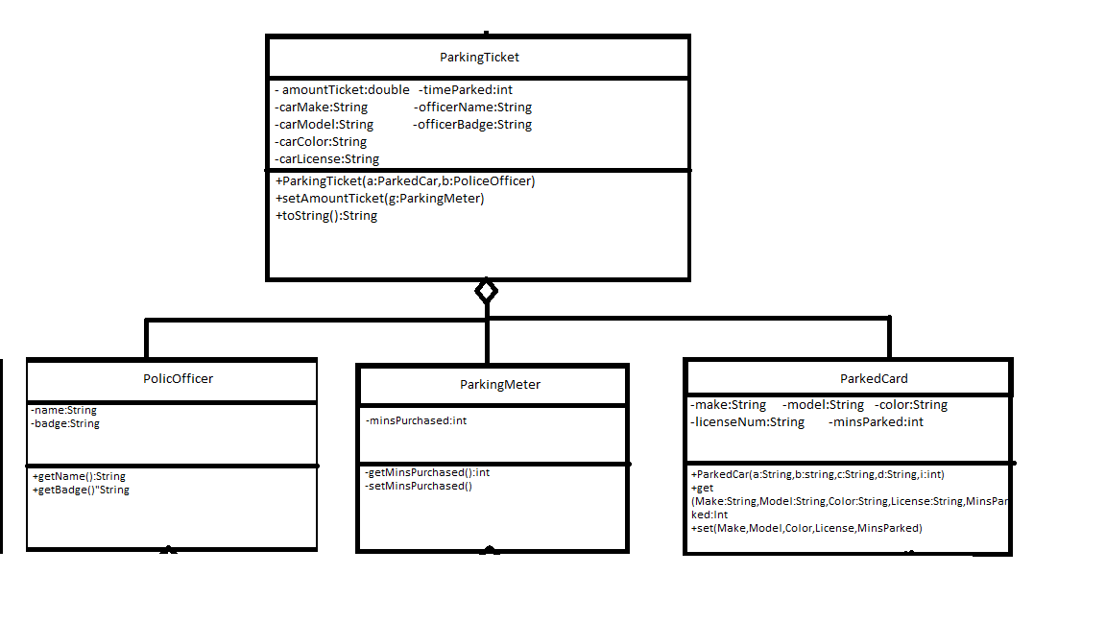

Step 3.

/\*-------------------  
Created by: NAthan Gaffney  
24-November-2014  
JAVA PROGRAMMING - CST-183-FA110-14FA-COURSE  
This class will create a ticket.  
Errors Handled: None  
Dependencies:   
ParkingTicket.class  
ParkedCar.class  
ParkingMeter.class  
PoliceOfficer.class  
Method:  
None  
---------------------\*/  
  
import javax.swing.JOptionPane;  
public class TicketDriver  
{  
 public static void main(String[] args)  
 {  
 String Make;  
 String Model;  
 String Color;  
 String License;  
 int purchased;  
   
 String offName;  
 String offBadge;  
 int timeParked;  
   
 Make = JOptionPane.showInputDialog("Enter car make:");  
 Model = JOptionPane.showInputDialog("Enter car model:");  
 Color = JOptionPane.showInputDialog("Enter car color:");  
 License = JOptionPane.showInputDialog("Enter car license number:");  
 purchased = Integer.parseInt(JOptionPane.showInputDialog("Enter amount of time purchased:"));  
 offName = JOptionPane.showInputDialog("Enter Officer's name:");  
 offBadge = JOptionPane.showInputDialog("Enter Officer's badge number:");  
 timeParked = Integer.parseInt(JOptionPane.showInputDialog("How long has the car been parked:"));  
   
 PoliceOfficer Officer = new PoliceOfficer(offName, offBadge);  
 ParkingMeter Pole = new ParkingMeter(purchased);  
 ParkedCar Car = new ParkedCar(Make, Model, Color, License, timeParked);  
 if( timeParked > purchased)  
 {  
 ParkingTicket ticket = new ParkingTicket(Car,Officer);  
 System.out.println("Ticket Issued.");  
 ticket.setAmountTicket(Pole);  
 System.out.print(ticket.toString());  
 }  
 else  
 {  
 System.out.println("No Ticket Issued.");  
 }  
   
 }  
}

public class ParkingTicket  
{  
 private double amountTicket;  
 //From ParkedCar  
 private String carMake;  
 private String carModel;  
 private String carColor;  
 private String carLicense;  
 private int timeParked;  
 //From PoliceOfficer  
 private String officerName;  
 private String officerBadge;  
 /\*\* This method is the constructor  
 @param a this will be a car object  
 ParkedCar will already have necessary information  
 @Param b this is a PoliceOfficer Object with information  
 \*/  
 public ParkingTicket(ParkedCar a, PoliceOfficer b)  
 {  
 carMake = a.getMake();  
 carModel = a.getModel();  
 carColor = a.getColor();  
 carLicense = a.getLicenseNum();  
 timeParked = a.getMinsParked();   
 //Set Officer Data  
 officerName = b.getName();  
 officerBadge = b.getBadge();  
 }  
 public void setAmountTicket(ParkingMeter g)  
 {  
 int extraTime;  
 extraTime = timeParked - g.getMinsPurchased();  
 if(timeParked<=60)  
 {  
 amountTicket = 25;  
 }  
 else  
 {  
 amountTicket = 25 + 10\*(extraTime/60);  
 }  
 }  
 public String toString()  
 {  
 String string;  
 string = "Ticketing Officer: " + officerName+"\n" +  
 "Badge Number: " + officerBadge+"\n"+  
 "Car Make: " + carMake+"\n"+  
 "Car Model: " + carModel+"\n"+  
 "Car Color: " + carColor+"\n"+  
 "License Plate: " + carLicense+"\n"+  
 "Ticket Total: " + amountTicket;  
 return string;  
 }  
}

/\*  
Created by Nathan Gaffney  
24/NOV/2014  
Create a model of a parked car  
\*/  
public class ParkedCar  
{  
 private String make;  
 private String model;  
 private String color;  
 private String licenseNum;  
 private int minsParked;   
   
 public ParkedCar(String a, String b, String c, String d, int i)  
 {  
 make=a;  
 model=b;  
 color=c;  
 licenseNum=d;  
 minsParked= i;  
 }  
 public String getMake()  
 {  
 return make;  
 }  
 /\*\*  
 This method will set the make.  
 @param make this is what the make will become  
 \*/  
 public void setMake(String s)  
 {  
 make = s;  
 }  
 public String getModel()  
 {  
 return model;  
 }  
 /\*\*  
 This method will set the model field.  
 @param model this is what the model will become  
 \*/  
 public void setModel(String s)  
 {  
 model = s;  
 }  
 public String getColor()  
 {  
 return color;  
 }  
 /\*\*  
 This method will set the color field.  
 @param color this is what the color will become  
 \*/  
 public void setColor(String s)  
 {  
 color = s;  
 }  
 public String getLicenseNum()  
 {  
 return licenseNum;  
 }  
 /\*\*  
 This method will set the channel field.  
 @param licenseNum this is what the licenseNum will become  
 \*/  
 public void setLicenseNum(String s)  
 {  
 licenseNum = s;  
 }  
 public int getMinsParked()  
 {  
 return minsParked;  
 }  
 /\*\*  
 This method will set the minParked field.  
 @param minsParked how long the car has been parked  
 \*/  
 public void setMinsParked(int n)  
 {  
 minsParked = n;  
 }  
}

/\*Created by Nathan Gaffney  
24/NOV/2014  
Create a simulation of a parking meter  
Store the time purchased  
Methods:  
getMinsPurchased  
setMinsPurchased  
\*/  
public class ParkingMeter  
{  
 private int minsPurchased;  
   
 public ParkingMeter(int a)  
 {  
 minsPurchased = a;  
 }  
 /\*\*This method will get the amount of time purchased  
 @return return the minsPurchased  
 \*/  
 public int getMinsPurchased()  
 {  
 return minsPurchased;  
 }  
 /\*\* This method will set the number of minutes purchased  
 @param t the amount of time to be bought  
 \*/  
 public void setMinsPurchased(int t)  
 {  
 minsPurchased = t;  
 }  
}

/\*Created by Nathan Gaffney  
24/11/2014a PoliceOfficer Object  
\*/  
public class PoliceOfficer  
{  
 private String name;  
 private String badge;  
   
 public PoliceOfficer(String a, String b)  
 {  
 name = a;  
 badge = b;  
 }  
   
 public String getName()  
 {  
 return name;  
 }  
 public String getBadge()  
 {  
 return badge;  
 }  
}

Output:

ÏÏÏÏ  
ÏÏ«Ï ----jGRASP exec: java TicketDriver  
ÏÏ§Ï  
ÏÏ§ÏTicket Issued.  
ÏÏ§ÏTicketing Officer: Officer  
ÏÏ§ÏBadge Number: Badge  
ÏÏ§ÏCar Make: Make  
ÏÏ§ÏCar Model: Model  
ÏÏ§ÏCar Color: COlor  
ÏÏ§ÏLicense Plate: 12345  
ÏÏ§ÏTicket Total: 65.0  
ÏÏ©Ï ----jGRASP: operation complete.